6.2

1. Import the Titanic Dataset from the link Titanic Data Set.

test <- read.csv("C:/Users/satish/Desktop/test.csv")

> View(test)

> train <- read.csv("C:/Users/satish/Desktop/train.csv")

> View(train)

Perform the following:

a. Is there any difference in fares by different class of tickets?

Note - Show a boxplot displaying the distribution of fares by class

data.combined$Pclass<-as.numeric(data.combined$Pclass)

> data.combined$Fare<-as.numeric(data.combined$Fare)

> boxplot(Fare~Pclass, data = data.combined,col= c("blue"))

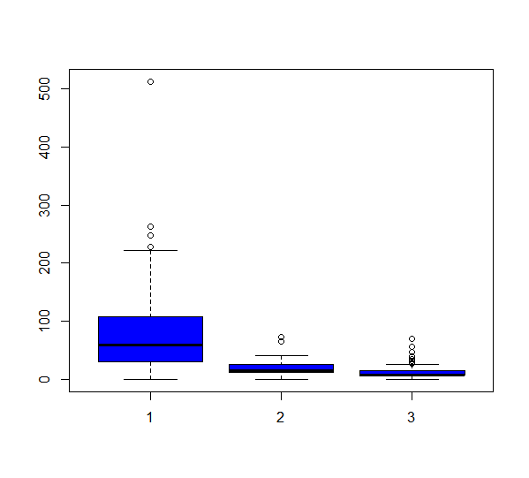

b. Is there any association with Passenger class and gender?

Note = show a stacked bar chart

|  |
| --- |
| mixed<-table(data.combined$Sex,data.combined$Pclass)  > mixed    1 2 3  female 144 106 216  male 179 171 493  > barplot(mixed, col = heat.colors(4),border="red", space=0.04,main = "stacked chart" ,  + xlab="passengerclass",ylab = "gender") |
|  |
| |  | | --- | | > | |

